Type the title of your paper here (17 pt Times New Roman)
Name Surname ¹, Name Surname ², Name Surname ³, …
¹ Author’s full postal address of affiliation including the country name
² Author’s full postal address of affiliation including the country name
³ Author’s full postal address of affiliation including the country name

Corresponding author’s institutional e-mail address (not @gmail, @yahoo, etc.)
Abstract
Start your abstract here… The abstract should include the purpose of research, principal results, and major conclusions. References should be avoided, if it is essential, only cite the author(s) and year(s) without giving the reference list. Prepare your abstract in this file and then copy it into the registration web field.
Keywords: Nanofluid; Cylindrical heating elements; Modification irreversibility number

- Introduction
State the objectives of the work and provide an adequate background, avoiding a detailed literature survey or a summary of the results.
After the first paragraph, other paragraphs are indented as you can see in this paragraph. After the Introduction, divide your article into clearly defined and numbered sections.
- Another section of your paper
Provide sufficient detail to allow the work to be reproduced. Methods already published should be indicated by a reference: only relevant modifications should be described. This section also may include theory, background, calculations which represent practical development from a theoretical basis. Etc.
After the first paragraph, other paragraphs are indented as you can see in this paragraph. Please use the Vancouver numerical system where references are numbered sequentially throughout the text. The numbers occur within square brackets, like this [2], and one number can be used to designate several references. The reference list gives the references in numerical, not alphabetical, order. Please ensure that every reference cited in the text is also present in the reference list (and vice versa). Unpublished results and personal communications are not recommended in the reference list.
Tables should be centered unless they occupy the full width of the text. Note that as a general principle, for large tables font sizes can be reduced to make the table fit on a page or fit the width of the text. If a table is divided into parts, these should be labeled (a), (b), (c), etc but there should only be one caption for the whole table, not separate ones for each part. Tables should be numbered sequentially throughout the text and referred to in the text by number (table 1, not tab. 1 etc). Captions should be placed at the top of the table and should have a full stop (period) at the end. Except for very narrow tables with a wide caption (see examples below) the caption should be the same width as the table. Tables should have only horizontal rules and no vertical ones. Generally, only three rules should be used: one at the top of the table, one at the bottom, and one to separate the entries from the column headings. Table rules should be 0.5 points wide. An example is given below.
Table 1. A slightly more complex table with ...
 | Wake Chi Sqr. (N=15, df=1) | p | Stage 1 Chi Sqr. (N=15, df=1) | p | Stage 2 Chi Sqr. (N=15, df=1) | p
F3 | 1.143ª | 0.285^{b} | 0.286 | 0.593 | 0.286 | 0.593
Fz | 1.143 | 0.285 | 0.067 | 0.796 | 0.067 | 0.796
C4 | 2.571 | 0.109 | 0.600 | 0.439 | 1.667 | 0.197
ª If you need, notes are referenced using alpha superscripts.
Figures should be centered unless they occupy the full width of the text. Captions should be below the figure and separated from it by a distance of 6 points—although to save space it is acceptable to put the caption next to the figure. Figures should be numbered sequentially through the text—‘Figure 1’, ‘Figure 2’, and so forth and should be referenced in the text as ‘figure 1’, ‘figure 2’,… and not ‘fig. 1’, ‘fig. 2’, ….
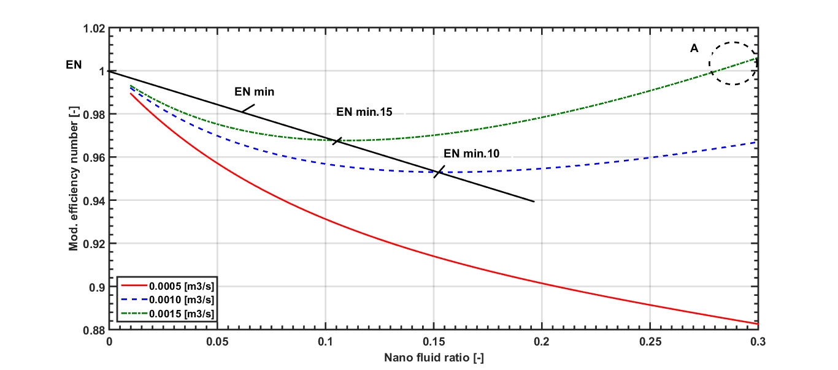
Figure 1. The modification efficiency number for ….

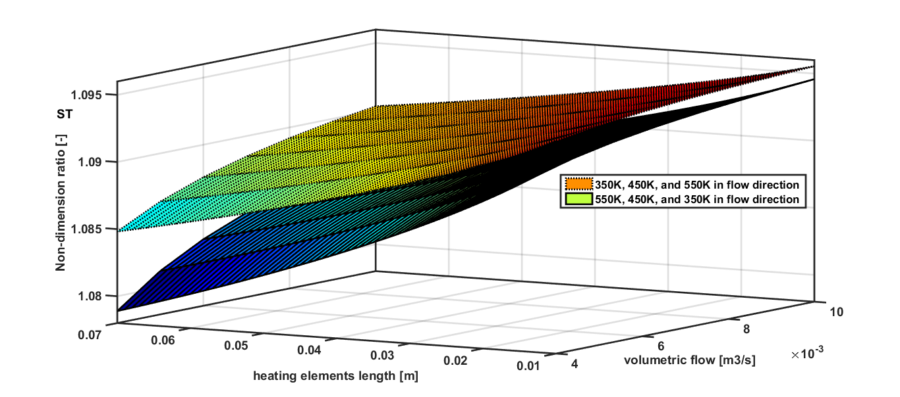
Figure 2. The non-dimensional ratios of the .....

Each figure should have a brief caption describing it and, if necessary, a key to interpreting the various lines and symbols on the figure. Authors should try to make economical use of the space on the page; for example: avoid excessively large white space borders around your graphics; try to design illustrations that make good use of the available space—avoid unnecessarily large amounts of white space within the graphic. Wherever possible try to ensure that the size of the text in your figures (apart from superscripts/subscripts) is approximately the same size as the main text (11 points). In general, try to avoid extremely fine lines (often called ‘hairline’ thickness) because such lines often do not reproduce well when printed out—your diagrams may lose vital information when downloaded and printed by other researchers. Try to ensure that lines are no thinner than 0.25 pt. Note that some illustrations may reduce line thickness when the graphic is imported and reduced in size (scaled down) inside Microsoft Word.
Equations: Make sure that your Equation Editor or MathType fonts, including sizes, are set up to match the text of your document. Number consecutively any equations that have to be displayed separately from the text (if referred to explicitly in the text). Please see example equation format:
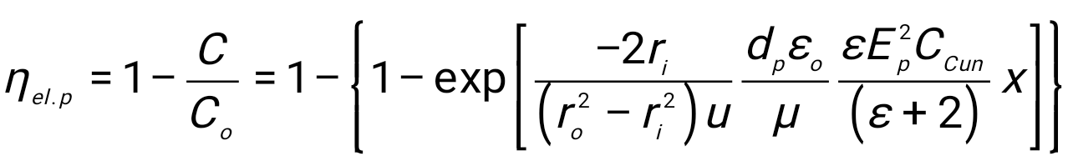 (1)
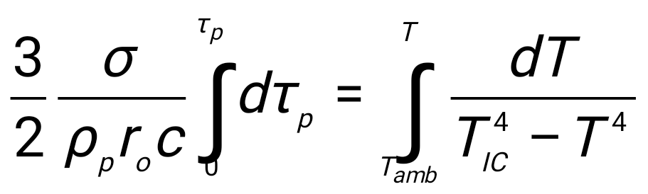 (2)
The following headings may also be used:
2.1. A subsection
Some text.
2.1.1. A subsubsection. The paragraph text follows on from the subsubsection heading but should not be in italic.
- Results and discussions
This should explore the significance of the results of the work, not repeat them. A combined Results and Discussion section is often appropriate. Avoid extensive citations and discussion of published literature.
- Conclusions
The main conclusions of the study may be presented in a short Conclusions section, which may stand alone or form a subsection of a Discussion or Results and Discussion section.
Acknowledgment(s)
Authors wishing to acknowledge assistance or encouragement from colleagues, special work by technical staff, or financial support from organizations should do so in an unnumbered Acknowledgments section immediately following the last numbered section of the paper.
References
- B.Andresen, J.M.Gordon, Optimal paths for minimizing entropy generation in a common class of finite-time heating and cooling processes. Int. J. Heat Fluid Flow.13, 294-299, (1992a)
- F.Alic,Thermal-hydraulic irreversibility of electrically heated impeller blades, Chemical Engineering Science,vol. 104, pp 549-556 (2013)
- H. J. Lugt, Vortex Flow in Nature and Technology _Wiley, New York, (1983)

